In the end the two questions I had about buying an electric vehicle were, can I get where I need to go, and how much money are they going to give us?

The first factor I looked into was the expansion of electric charging infrastructure. Even though the average American drives less than 50 miles a day and the average electric car battery range is 200 miles, there is still an element of uncertainty that the media and experts have dubbed “range anxiety”. Gas stations are abundant, but it’s a lot harder to spot a place to plug in your Tesla on a long road trip. There is nothing you can do if you are stranded with a dead battery in the middle of nowhere.

The National Renewable Energy Laboratory, a federal laboratory under the purview of the US Department of Energy, tracks the location and other data on Alternative Fuel Stations in the United States. They have an API available that allowed me to pull this data into a Pandas Data Frame.

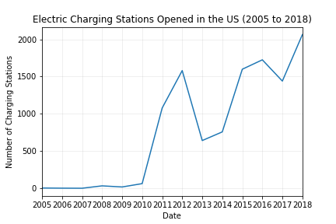I limited my pull to electric charging stations only and pull the opening date, latitude and longitude, state, and access type. I did not end up using the access type information in my final analysis, but if I had more time, I would want to see the spread of publicly available stations vs privately held stations.

I specifically looked at the opening date of each station and charted that over time. Our sales data for PEVs starts in 2010, when the first mass produced electric vehicles started to hit the market. We see a correlating explosion in the opening of EV charging stations. This continues and peaks in 2012, around the time when the Tesla Model S is released. There is drop and climb between 2012 and 2016, which is the year that Tesla releases the Model 3.

This could indicate a ramp up of infrastructure that proceeds the release of particularly popular PEV models. Given more time, I would attempt to chart the “enthusiasm” of the vehicles cited above using Google Trends and APIs for news sites for data on search hits and media coverage.

We do see an increase in the opening of charging stations, but is it enough?

Location matters. If there are ten stations in your home town, but none on the road to grandma, an electric car is still going to feel limiting.

The National Renewable Energy Laboratory released a report in September of 2017 theorizing the projected infrastructure needed to create unlimited access. The below graphic represents, in red, the range electric vehicles could travel in the US if there were charging stations on all major interstates.

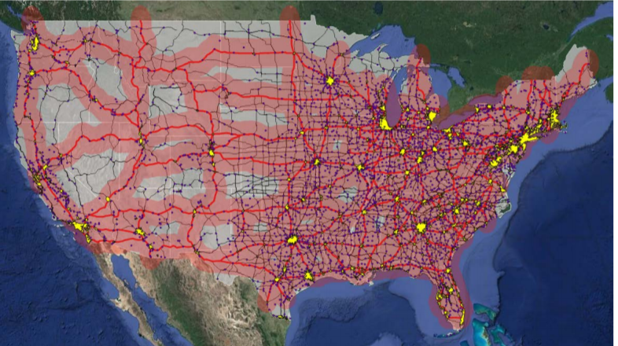

Using the Google Maps API, I created a heat-layer to show the location and density of the stations currently open in the United States, and as you can see, there is a ways to go.

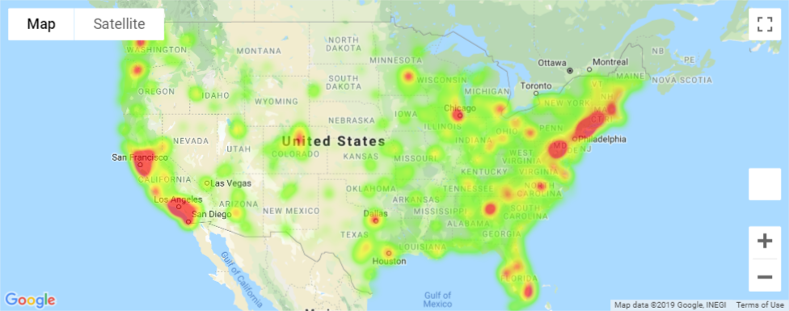

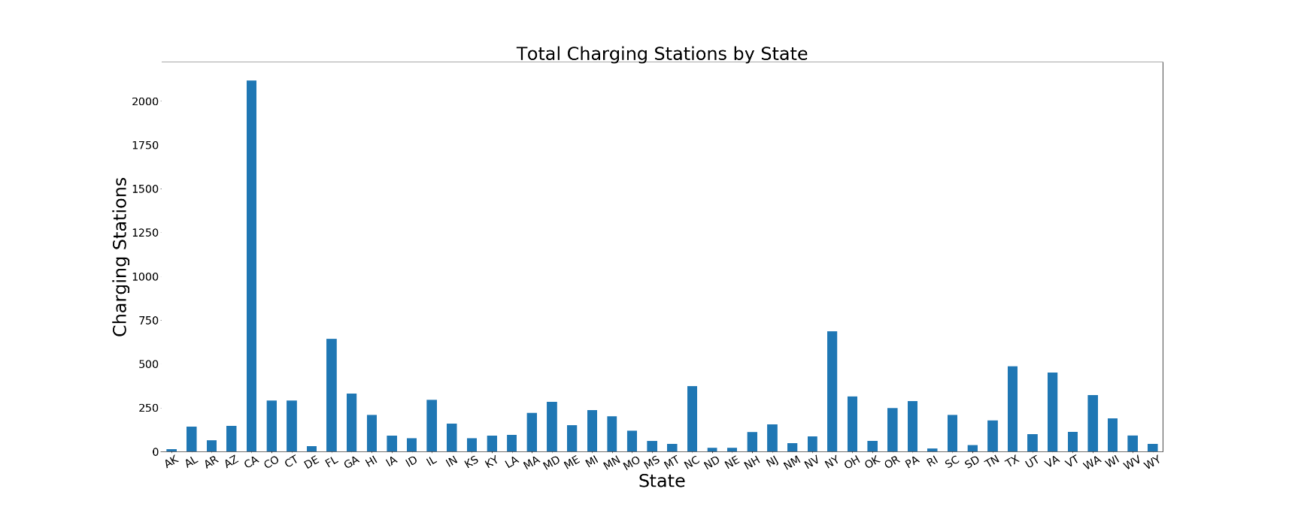Charging stations are grouped primarily around major metropolitan areas and the coasts. A large portion of the country remains underserved.

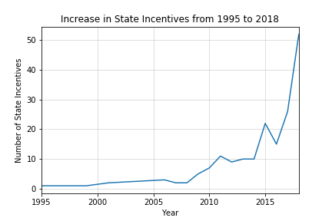

If I had more time, I would want to anaylze and breakdown the types of laws and incentives further. As part of my original analysis, I compared the charging station data to the incentive data by state and did not find an overwhelming correlation. If I could pick out which states have incentives specific to charging stations, I could see if these laws had an impact.

Also, it’s hard to tell from this anaylsis what types of incentives motivate consumers. In my personal experience, the tax breaks were a big factor in choosing an electric vehicle, yet the list of incentives pulled from NREL contained a wide breadth of laws. For example, one of Georgia’s incentives is the ability to use HOV lanes which, as anyone living in Atlanta knows, doesn’t matter because everything is 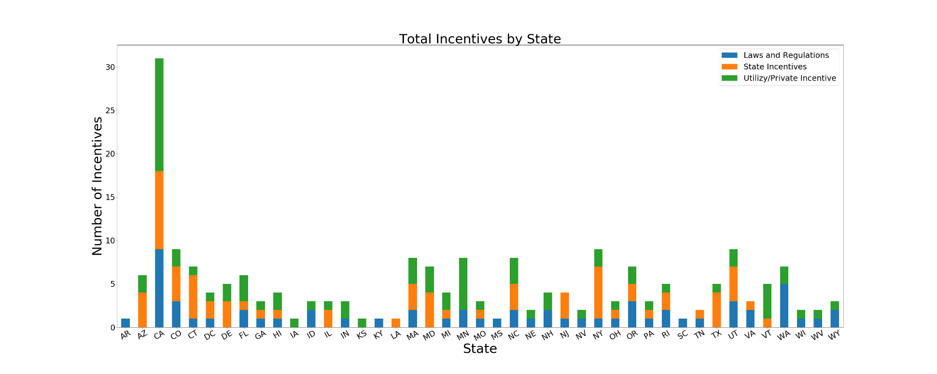gridlocked after 5:00PM anyway and would not sway anyone to buy a Tesla if they were on the fence.

Sources

* NREL Developer Tools (<https://developer.nrel.gov/>)
* National Plug-In Electric Vehicle Infrastructure Analysis (Sept 2017) from the US Department of Energy <https://www.nrel.gov/docs/fy17osti/69031.pdf>
* My nerd husband who spent way too much time researching a car when all I cared about was that it had an auxiliary cord.